**Chapter 1**

**INTRODUCTION**

The 'Campus Management System' has been developed to override the problems prevailing in the practicing manual system. This software is supported to eliminate and in some cases reduce the hardships faced by this existing system. Moreover this system is designed for the particular need of the company to carry out operations in a smooth and effective manner.

The application is reduced as much as possible to avoid errors while entering the data It also provides error message while entering invalid data No formal knowledge is needed for the user to use this system. Thus by this all it proves it is user-friendly. Campus Recruitment System . as described above. can lead to error free. secure. reliable and fast management system. It can assist the user to concentrate on their other activities rather to concentrate on the record keeping. Thus it will help organization in better utilization of resources.

Every organization, whether big or small, has challenges to overcome and managing the information of Company, College, Student, Placement, Vacancy. Every Campus Recruitment System has different College needs. therefore we design exclusive employee management systems that are adapted to your managerial requirements. This is designed to assist in strategic planning. and will help you ensure that your organization is equipped with the right level of information and details *for* your future goals. Also. for those busy executive who are always on the go. our systems come with remote access features. which **will** allow you to manage your workforce anytime , at all times. These systems will ultimately allow you to better manage resources.

**Chapter 2**

**SYSTEM ANALYSIS**

**2.1 LITERATURE SURVEY**

The old manual system was suffering from a series of drawbacks. Since whole of the system was to be maintained with hands the process of keeping. maintaining and retrieving the information was very tedious and lengthy. The records were never used to be in a systematic order. there used to be lots of difficulties in associating any particular transaction with a particular context. If any information was to be found it was required to go through the different registers. documents there would never exist anything like report generation. There would always be unnecessary consumption of time while entering records and retrieving records. One more problem was that it was very difficult to find errors while entering the records. Once the records were entered it was very difficult to update these records.

The reason behind it is that there is lot of information to be maintained and have to be kept in mind while running the business For this reason we have provided features Present system is partially automated (computerized). actually existing system is quite laborious as one has to enter same information at three different places..

**2.2PROPOSED SYSTEM**

* + 1. **SCOPE OF THE PROJECT**

It may help collecting perfect management in details . In a very short time , the collection will be obvious ,simple and sensible.it will help a person to know the management of passed year perfectly and vividly. It also helps in current all works relative to Campus Management System. it will be also reduced the cost of collecting the management and collection procedure will go on smoothly.

Our project aims at Business process automation. i.e. we have tried to computerize verious processes of Campus Recruitment System.

* In computer system the person has to fill the various forms & number of copies of the forms can be easily generated at a time.
* In computer system, it is not necessary to create the manifest but we can directly print it. which saves our time.
* To assist the staff in capturing the effort spent on their respective working areas.
* To utilize resources in an efficient manner by increasing their productivity through automation.
* The system generates types of information that can be used for various purposes.
* It satisfy the user requirement.
* Be easy to understand by the user and operator
* Be easy to operate
* Have a good user interface
* Delivered on schedule within the budget

**2.2.2 AIM OF THE PROJECT**

The aim of proposed system is to develop a system of improved facilities. The proposed system can overcome all the limitations of the existing system. The system provides proper security and reduces the manual work

* Security of data.
* Ensure data accuracy's.
* Proper control of the higher officials.
* Minimize manual data entry.
* Minimum time needed for the various processing.
* Greater efficiency.
* Better service.
* User friendliness and interactive.
* Minimum time required.

**Chapter 3**

**REQUIREMENT SPECIFICATIONS**

**3.1 SYSTEM REQUIREMENTS**

A database management system (DBMS) consists of several components . Each component plays very important role in database management system environment. The major components of database management system are :

* Software
* Hardware
* Data
* Procedures
* Database Access Language

Here we would be explaining hardware and software requirements of our database project .

**3.1.1. HARDWARE CONFIGURATION**

RAM  :  1 GB and above

Hard Disk:  60 GB and above

**3.1.2. SOFTWARE CONFIGURATION**

Front end: Sublime/php

Back end: Mysql

Server : XAMP

**3.2 DEVELOPMENT ENVIRONMENT**

# DESIGN FEATURES

# OPEN SOURCE:

# PHP is freely available for use. The community of open source PHP developers provides technical support and is constantly improving updating the core PHP functionalities. PHP is available at free of cost under PHP General Public License and most of its associative required software's like MySQL, Text Editors and Apache Server are also freely available, so it proves very cost effective for the developers.

**CROSS PLATFORM:**

PHP provides high compatibility with leading operating systems and web servers such as thereby enabling it to be easily deployed across several different platforms .PHP scripts can run across operating systems such as Linux, Windows, Solaris, OpenBSD, Mac OSX etc and also provide support for all major web servers such as Apache, IIS, iPlanet etc.

**POWER:**

Several web tasks can now be easily perform using PHP. For example now we can develop from small websites to giant business and organizational websites, informative forums, chatting platforms, CRM solutions, e-commerce shopping carts, community websites, e-business

**USER FRIENDLY:**

Designed in a user friendly manner, PHP gives more flexibility than C, C++ and ASP and overall helps in increasing traffic to the site.

**QUICK:** PHP is designed to work well with the web, and so things like accessing the GET and POST and working with HTML and URLs are built-ins in the PHP language. This makes it really concise and straightforward to make a website.

**EXTENSIONS:**

Being an open source language, a large number of libraries and extensions, to extend its core functionalities, are available for download. The source code of PHP can be modified to include custom created extensions and components thereby increasing its extensibility.

**EASY DEPLOYMENT:**

There are many hosting companies that will, for a few dollars a month, give you a server running PHP so you can make a website really easily.

**AUTOMATICALLY REFRESHES:**

Now a days developing dynamic websites are in the huge demand due to its specific characteristics like manually.

**COMMUNITY SUPPORT:**

A huge advantage that PHP offers is its community. If you are looking for a particular script, chances are another user has already created something similar. Check within the PHP community for availability. Likewise, if you have created a function that others might enjoy, be sure to post the code for others.

**OTHERS TOOLS:**

If you need to access other web based tools like Google maps (which is always advisable for a business website), or any other, PHP makes it easy to access.

**TALENT AVAILABILITY:**

You can hire PHP programmers more easily than any other language programmers since so many people know the language.

**INTRODUCTION TO MYSQL**

**Mysql is a powerful database. It’s very good and free of change. Many developers in the world selected Mysql and php for developing their website.**

**The Mysql database has become the world’s most popular open source database because of its consistent fast performance, high reliability and easy of use. It’s used in more than 6 million installations ranging from large corporations to specialized embedded applications on every continent in the world.**

**Not only is Mysql the world’s most popular open source database, it’s also become the database of choice for a new generation of applications built on the LAMP stack(Linux, Apache, Mysql, php / Perl / python.) Mysql runs on more than 20 platforms including Linux, Window, OS/X, HP-UX, AIX, Netware, giving you the kind of flexibility that puts you in control.**

**Whether you’re new to database technology or an experienced developer or DBA, Mysql offers a comprehensive range of certified software, support, training and consulting to make you successful .**MYSQL is a free, widely used SQL engine. It can be used as a fast database as well as a rock-solid DBMS using modular engine architecture.

**MYSQL LANGUAGE**

DDL (Data Definition Language) refers to the CREATE, ALTER and DROP statements.

DDL allows adding / modifying / deleting the logical structures which contain the data or which allow users to access / maintains the data (databases, tables, keys, views...). DDL is about "metadata".

DCL is used to grant / revoke permissions on databases and their contents. DCL is simple, but MYSQL's permissions are rather complex. DCL is about security.

**MY SQL HOMEPAGE**

**1. SCALABILITY AND FLEXIBILITY**

The Mysql database server provides the ultimate in scalability, sporting the capacity to handle deeply embedded applications with a footprint of only 1MB to running massive data warehouses holding terabytes of information.

**2. HIGH PERFORMANCE**

A unique storage-engine architecture allows database professional to configure the Mysql database server specifically for particular applications, with the end result being amazing performance results.

**3. HIGH AVAILABILITY**

Rock-solid reliability and constant availability are hallmarks of Mysql, with customers relying on Mysql to guarantee around-the-clock uptime.

**4. ROBUST TRANSACTIONAL SUPPORT**

Mysql offers one of the most powerful transactional database engines on the market. Features include complete ACID (atomic, consistent, isolated, durable) transaction support, unlimited row-level locking, distributed transaction capability, and multi-version transaction support where readers never block writers and vice-versa.

**5. WEB AND DATA WAREHOUSE STRENGTHS**

Mysql is the de-facto standard for high-traffic website because of its high-performance query engine, tremendously fast data inserts capability, and strong support for specialized web functions like fast full text searches.

**6. STRONG DATA PROTECTION**

Because guarding the data assets of corporations is the number one job of database professionals, Mysql offers exceptional security features that ensure absolute data protection.

**7. COMPREHENSIVE APPLICATION DEVELOPMENT**

One of the reasons Mysql is the world’s most popular open source database is that it provides comprehensive support for every application development need.

**8. MANAGEMENT EASE**

This rule holds true whether the platform is Microsoft Windows, Linux, or UNIX. Once installed, Self-management features like automatic space expansion, auto-restart, and dynamic configuration changes take much of the burden off already overworked database administrators.

**XAMPP**

It is a free and open source cross platform web server solution stack package developed by Apache . It is simple , lightweight Apache distribution that makes it extremely easy for developers to create a local web server for testing and deployment purposes . Xampp is also cross-platform , which means it works equally well on Linux , Mac and windows . Since most actual web server deployments use the same components as XAMPP , it makes transitioning from a local test server to a live server extremely easy as well .

**XAMPP CONTROL PANEL**

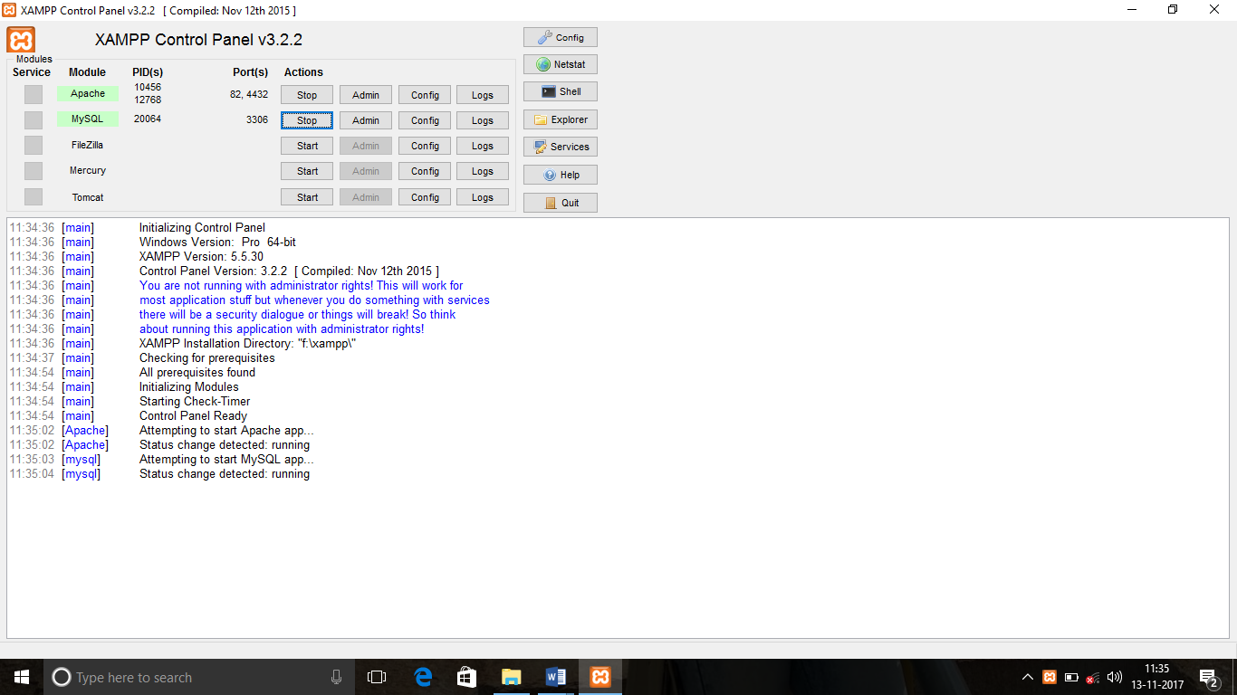

**BOOTSTRAP - WEB FRONT END FRAMEWORK**

Bootstrap is the most popular HTML, CSS, and JS framework for developing responsive, mobile first projects on the web. Bootstrap makes front-end web development faster and easier. It's made for folks of all skill levels, devices of all shapes, and projects of all sizes. 

**Chapter 4**

**SYSTEM DESIGN**

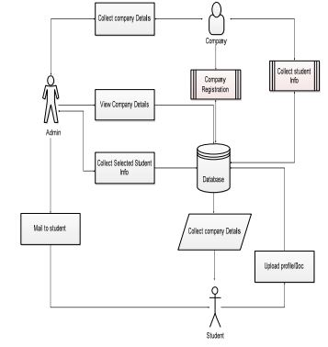

**FIG 5.1 SYSTEM DESIGN OF CAMPUS MANAGEMENT SYSTEM**

**Chapter 5**

**SYSTEM IMPLEMENTATION**

**5.1 MODULES DESCRIPTION**

 MODULES:

Campus Management System' provides the modules like

• Student

• College

• Company

1. STUDENT MODULE: In this module, creation of student input records about academic career from SSLC, HSC and all semester with facilities to modify the records and viewing changed records. The Student views the company details and verifies particular company details and provides valid details for registration.
2. COMPANY MODULE: The company enrols themselves and they register their profile and their will marquee in the main page till their drive and view the student’s details and update their details. Login Company, registration, students details view

C. COLLEGE MODULE: The college having the placement officer who views the students details and company details and post the selected students list. Sending email to student for complete list of information for particular campus. Indication of hall ticket issued to candidates through mail. Login, View company details, View selected students details, Sending mail.

**Chapter 6**

**SAMPLE OUTPUTS**

**6.1 SCREENSHOTS**

**INDEX PAGE**

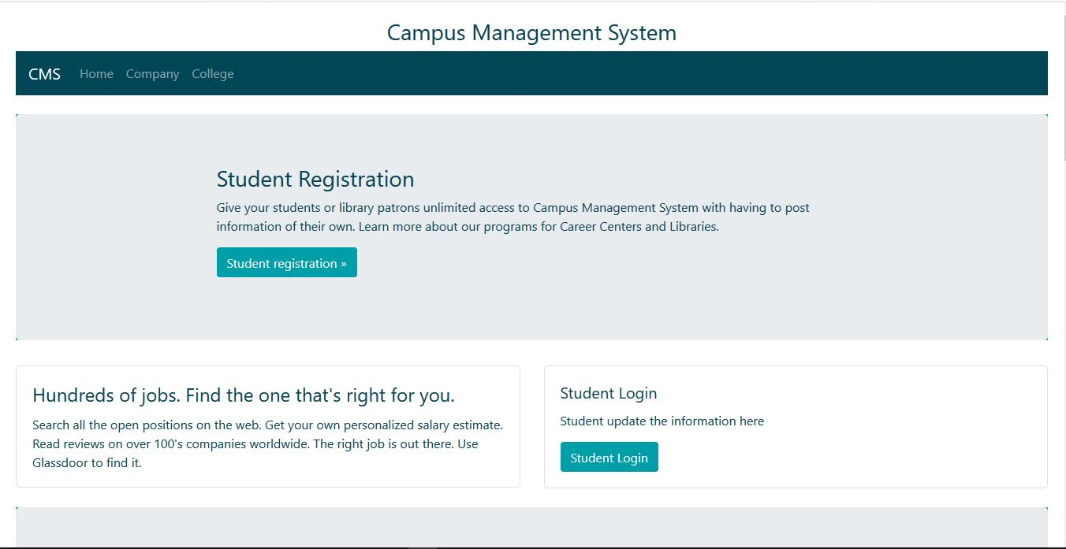

**[STUDENTS REGISTRATION FORM :](https://www.jotform.com/form-templates/students-registration-form)**

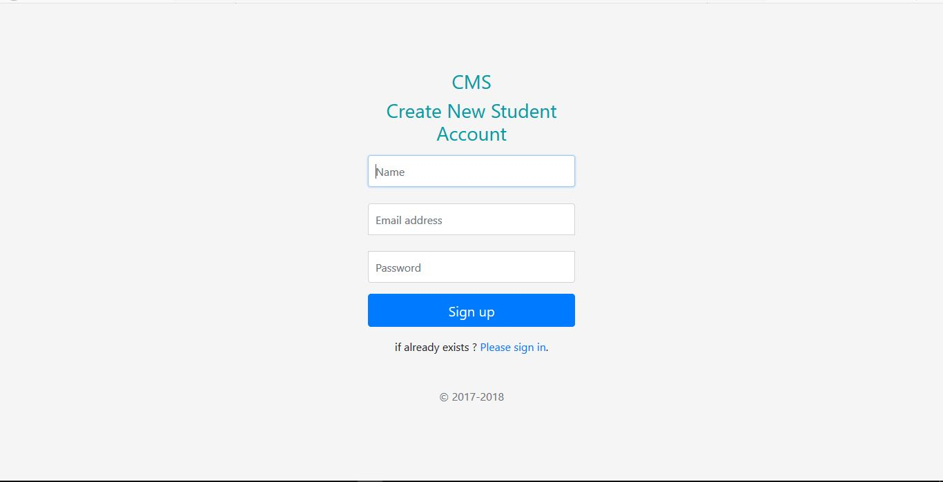

**STUDENT LOGIN FORM:**

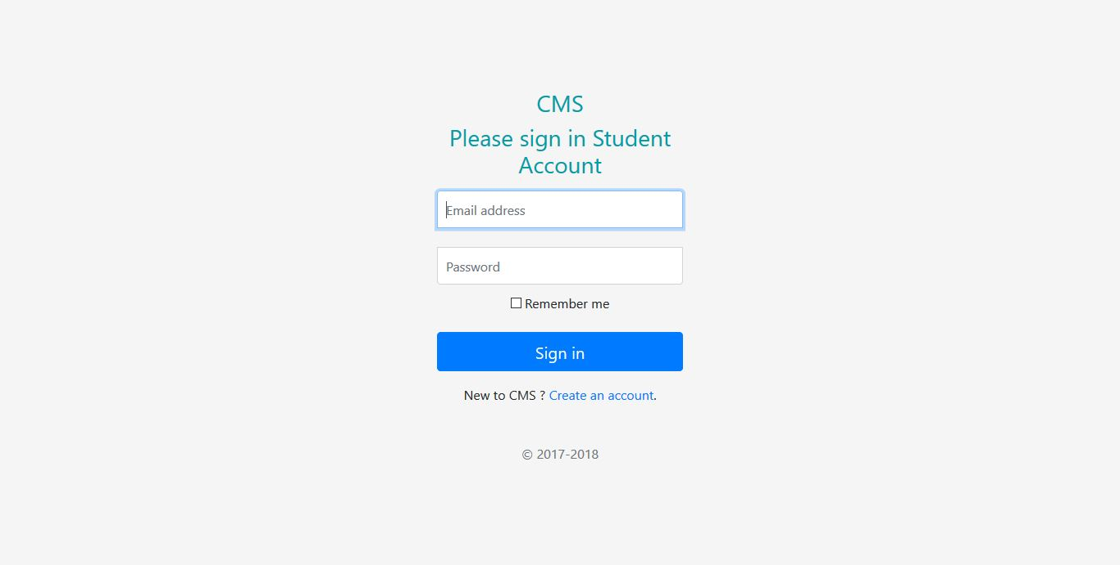

**[STUDENT DASHBOARD:](https://www.tynker.com/dashboard/student/)**

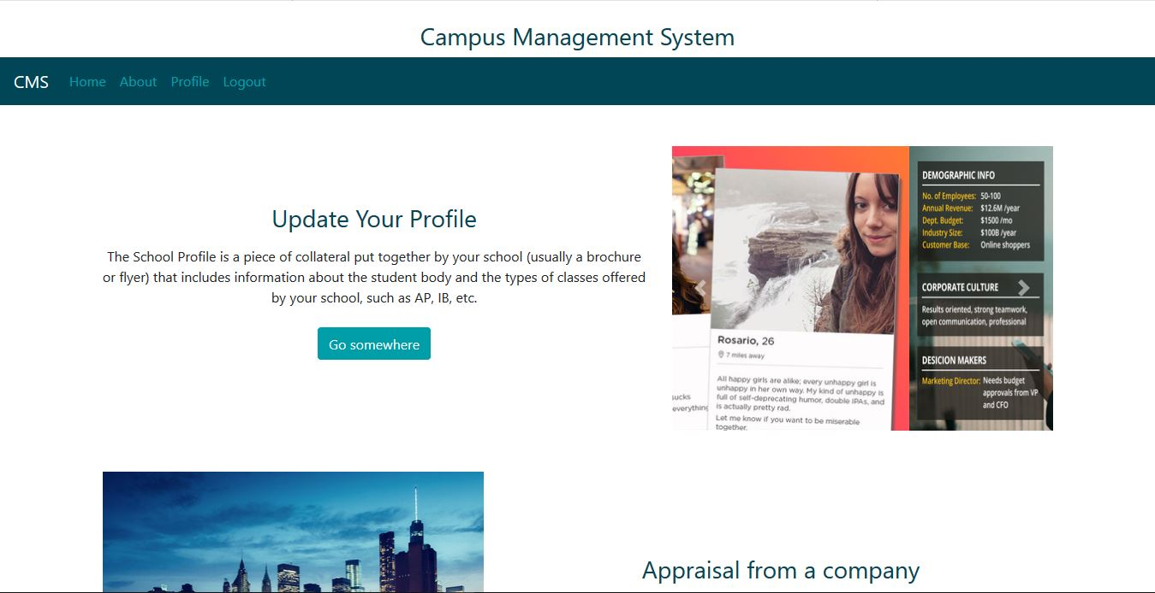

**[COMPANY DASHBOARD :](https://www.scoro.com/company-reporting-dashboard/)**

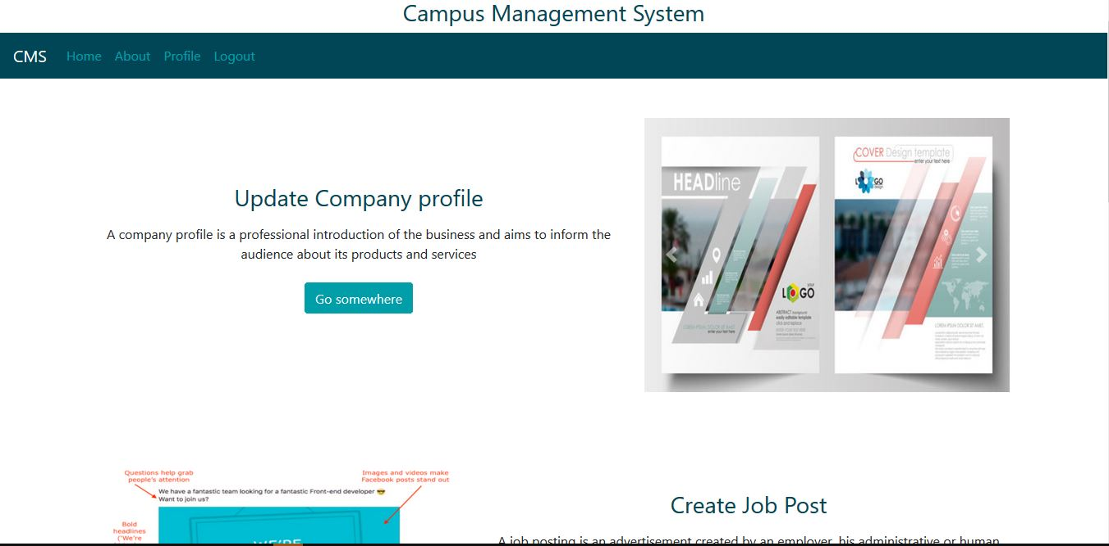

**COLLEGE DASHBOARD :**

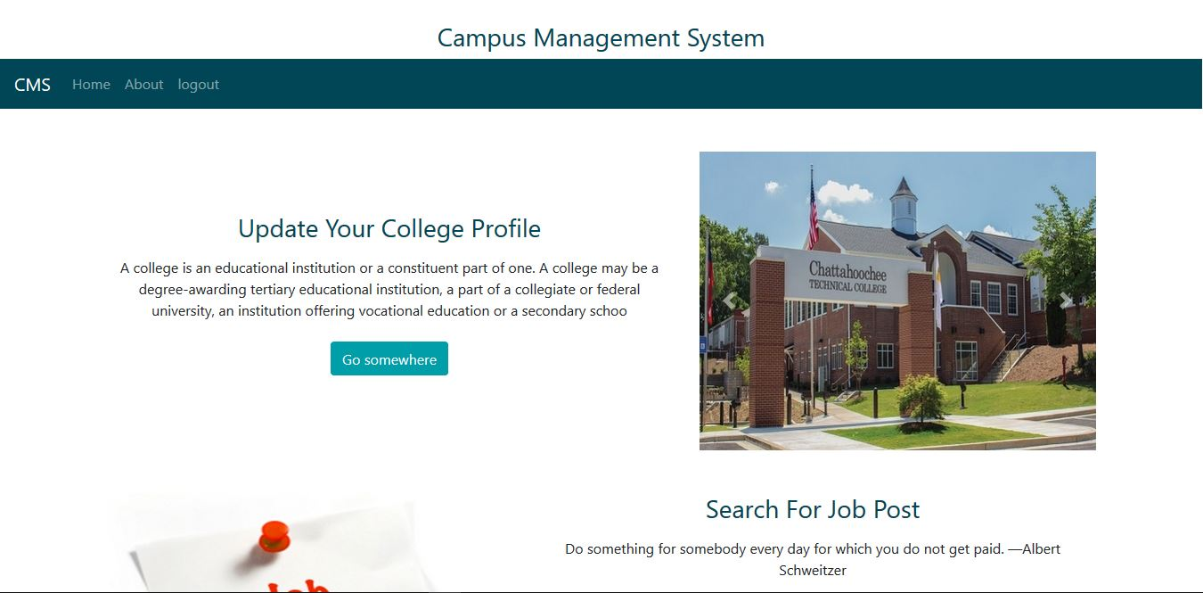

**COMPANY PROFILE UPDATION FORM:**

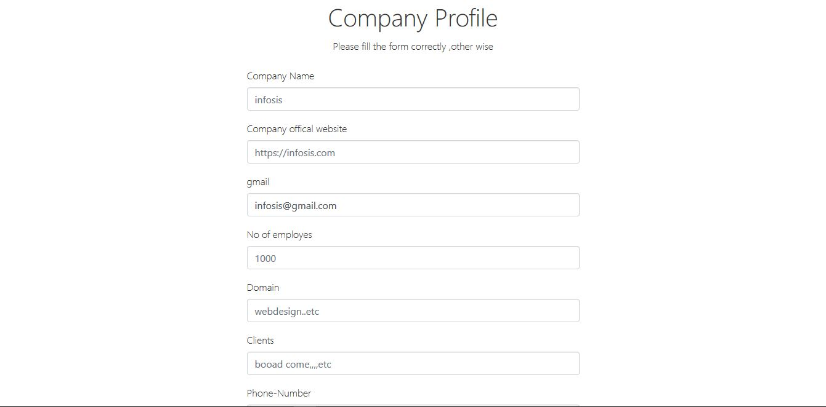

**JOB POST FORM:**

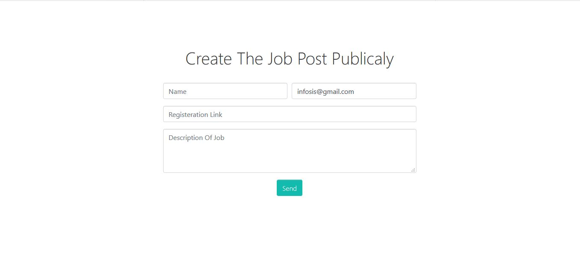

**JOB POSTS:**

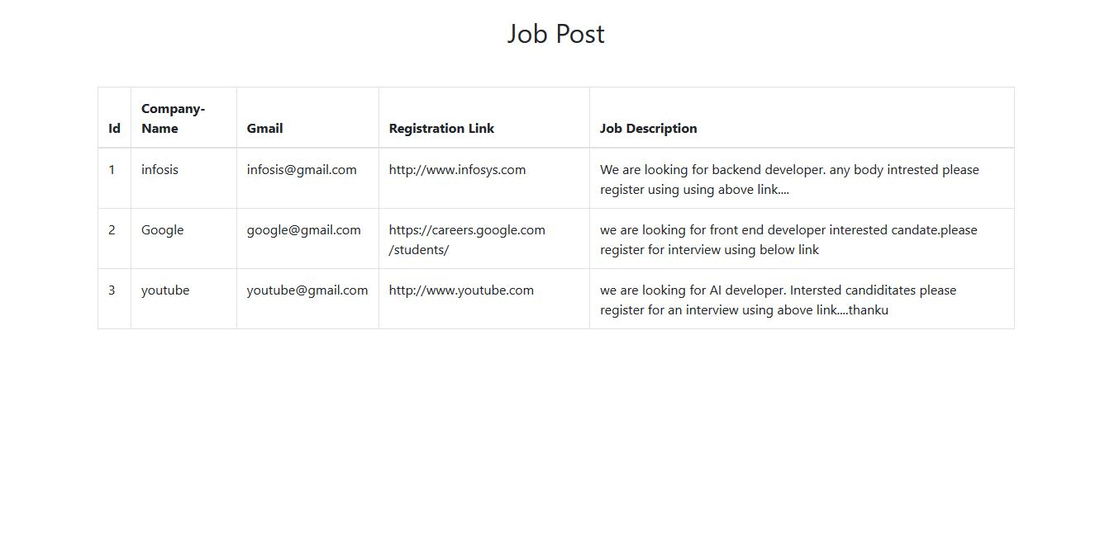

**COLLEGE PROFILE UPDATION FORM:**

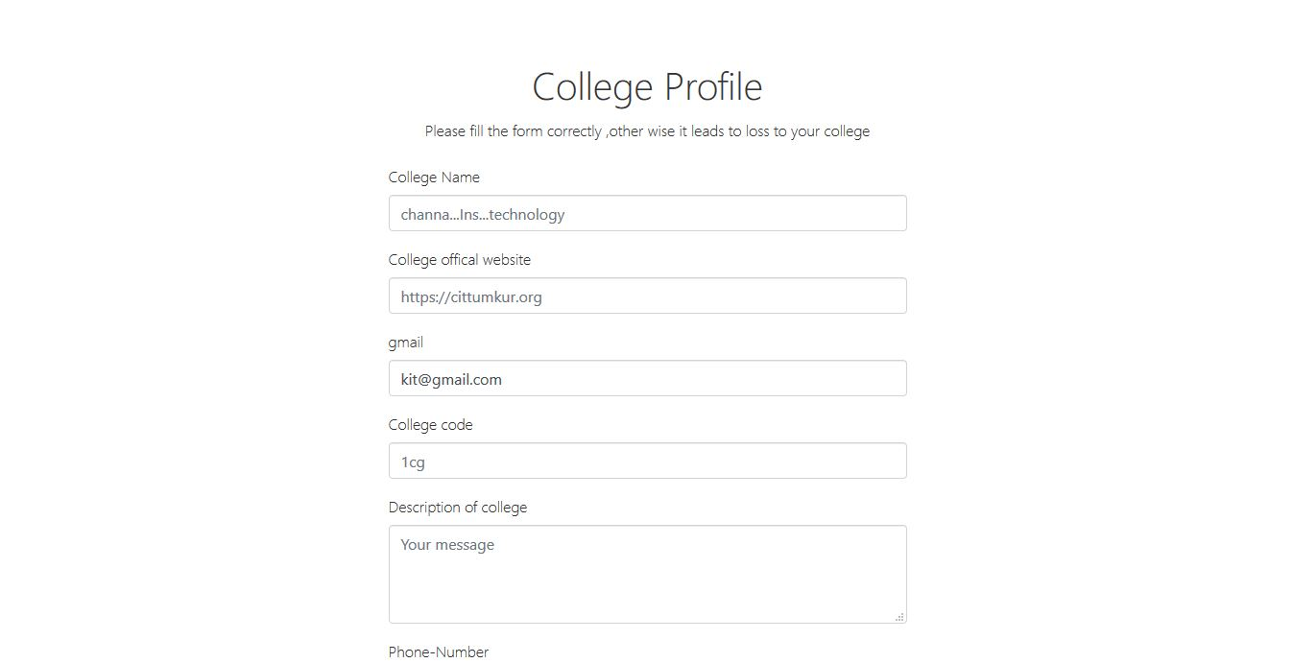

**CONCLUSION**

Our project is only a humble venture to satisfy the needs to manage their project work. Several user friendly coding have also adopted. This package shall prove to be a powerful package in satisfying all the requirements of the school. The objective of software planning is to provide a frame work that enables the manger to make reasonable estimates made within a limited time frame at the beginning of the software project and should be updated regularly as the project progresses.

At the end it is concluded that we have made effort on following points...

• A description of the background and context of the project and its relation to work already done in the area.

• Made statement of the aims and objectives of the project.

• The description of Purpose, Scope, and applicability.

• We define the problem on which we are working in the project.

• We describe the requirement Specifications of the system and the actions that can be done on these things.

• We understand the problem domain and produce a model of the system, which describes operations that can be performed on the system.

• We included features and operations in detail, including screen layouts.

**REFERENCES**

# Html & css : the complete reference, fifth edition

* http://www.php.net.
* <http://en.wikibooks.org/wiki/MySQL>
* <https://www.w3schools.com/php/>
* [www.google.com](http://www.google.com)
* [www.wiki.com](http://www.wiki.com)